
SYRICI

Etpyrafen
CIPAC Collaborative Trial
CIPAC 5142R, small scale study

CIPAC Collaborative Study of a
High Performance Liquid Chromatographic Analysis of Etpyrafen Technical Material and Formulated Products

By
Ms Wang Haixia
Shenyang Research Institute of Chemical Industry Co., Ltd
Pesticides Test Laboratory
No.8, Shenliao Dong Road, Tiexi District, Shenyang City,
P. R. of China

Presented at the CIPAC meeting in Panama
June, 2018

Pages: 11
Table of Contents

1. List of Participants 3
2. General Information 3
3. Distribution of Samples 5
4. Procedure 5
4.1. Outline of Method 5
4.2. Program of Work 5
5. Analytical Methods 5
5.1. Analytical Conditions 5
5.2. Deviations from the Analytical Method 6
5.3. Remarks about the Analytical Method 7
6. Statistical Evaluation 7
7. Results 8
8. Summary of the results 14
9. Statistical formulas 14
10. Discussion 15

List of Participants
7 laboratories took part in the collaborative study:
NAME | ORGANIZATION | COUNTRY
Suping Bao | National Supervising & Testing Center for Pesticide (Nanjing) | China
Yue Wang | Nutrichem Laboratory Co., Ltd. | China
Pei Wu | Shandong Academy of Pesticide Sciences Testing Center | China
Laiwei Xu | Test Center for Chemical Products of Zhejiang Chemical Industry Research Institute | China
Rose Feng | Jiangsu Rotam Chemistry Co., Ltd | China
Bo Wang | Pesticides Test Laboratory of Shenyang Research Institute of Chemical Industry (PTLSY) | China
Qinghua Zhao | China National Pesticide Quality Supervision Testing Center (Shenyang) CNPTC | China

General Information
Etpyrafen
TC/M/
ISO Common name Etpyrafen
Chemical name (Z)-2-(4-tert-butylphenyl)-2-cyano-1-(1-ethyl-3- methylpyrazol-5-yl)vinyl2,2-dimethylpropionate (IUPAC)
(1Z)-2-cyano-2-[4-(1,1-dimethylethyl)phenyl]-1-(1-
ethyl-3-methyl-1H-pyrazol-5-yl)ethenyl,2-dimethyl
propanoate (CA, 1253429-01-4)
Empirical formula C₂₄H₃₁N₃O₂
RMM 393.53
m.p. 97.2°C~98.6℃
v.p. 8.9×10⁻⁸ Pa at 20°C
Solubility In water 0.0890 mg/L at 20°C; In methanol 114~ 133 g/L, hexane 29~33 g/L. In acetone, dichloromethane, xylene, ethyl acetate >250 g/L
Stability Stable for 14 d at 54 ℃
Description The pure material is a white, odorless solid
Formulation Suspension concentrates (SC)

Distribution of Samples
The following samples were provided to the participants:

Reference standard of Etpyrafen 0.5 g
Lot No. 20171207, purity: 995 g/kg

Etpyrafen technical (TC1) 20 g
Batch No. 1711380, approx. 980 g/kg

Etpyrafen 30% suspension concentrate (SC1) 50 mL
Batch No. 171283A, approx. 300 g/kg

Etpyrafen 30% suspension concentrate (SC2) 50 mL
Batch No. 171269A, approx. 300 g/kg

Procedure

Outline of Method
Etpyrafen in the test substance is determined by HPLC method with a C₁₈ reverse phase column and UV detection at 230 nm. The analyte solution contains about 40 mg of Etpyrafen in 100 mL solution.

Program of Work

We requested the collaborators to:
1) conduct duplicate determinations on two different days for each of the three samples;
2) inject each sample solution in duplicate and calculate the mean value;
3) check equilibration of the system before the determination;
4) describe operating conditions in detail; and
5) attach the typical chromatograms for the three samples.

Analytical Methods

Analytical Conditions
Lab | Liquid chromatograph integrator | Column | Mobile phase | Flow rate (mL/min) | Column temp (℃)
Proposed Conditions |  | Agilent ZORBAX SB C₁₈, 150×4.6mm (i.d.), 5μm | acetonitrile-0.05% phosphoric acid solution, 800 + 200 (v/v) | 1.0 | 30
1 | DIONEX Utimate 3000 | Agilent ZORBAX SB C₁₈, 250×4.6 mm (i.d.), 5μm | acetonitrile - 0.05% phosphoric acid solution, 800 + 200 (v/v) | 1.35 | 30
2 | Agilent1260 | Agilent ZORBAX SB C₁₈, 150×4.6mm (i.d.), 3.5um | acetonitrile - 0.05% phosphoric acid solution, 800 + 200 (v/v) | 1.0 | 30
3 | SHIMADZU LC-20AT | InertSustain C₁₈ 250×4.6 mm (i.d.), 5μm | acetonitrile - 0.05% phosphoric acid solution, 800 + 200 (v/v) | 1.0 | 40
4 | Dionex Ultimate 3000 | ZORBAX SB C₁₈, 150×4.6mm (i.d.), 5µm; | acetonitrile - 0.05% phosphoric acid solution, 800 + 200 (v/v) | 1.0 | 30
5 | SHIMADZU 20A | Agilent C₁₈, 150×4.6mm (i.d.), 5μm | acetonitrile - 0.05% phosphoric acid solution, 800 + 200 (v/v) | 1.0 | 30
6 | Thermo Dionnex U3000 | Agilent ZORBAX SB C₁₈ 150×4.6mm (i.d.), 5μm | acetonitrile - 0.05% phosphoric acid solution, 800 + 200 (v/v) | 1.0 | 30
7 | Waters 1525 Serial | Agilent Extend C₁₈ 150×4.6mm (i.d.), 5 μm | acetonitrile - 0.05% phosphoric acid solution, 800 + 200 (v/v) | 1.0 | 30

Deviations from the Analytical Method
Lab 1: The length of column is longer and the Flow rate is faster，but equivalent with the same selectivity.

Lab 2: The column model in the given method is changed from Agilent ZORBAX SB C₁₈ 150×4.6mm (i.d.), 5.0 um to Agilent ZORBAX SB C₁₈ 150×4.6mm (i.d.), 3.5um.

Lab 3: The column is InertSustain C18 250mm×4.6 mm,5μm, and the column temp is 40℃.

Lab 4: 1) The weighed mass of Etpyrafen reference standard and Etpyrafen sample is changed. Described in the proposed method: For Etprafen reference standard, technical sample and SC: 40 mg, 40 mg and 130 mg; In actual operation: 20 mg, 20 mg and 70 mg; 2) The diluted volume of Etyprafen reference standard and Etpyrafen sample is changed. Described in the proposed method: 100 ml; In actual operation: 50 ml.

Lab 5: No deviations.

Lab 6: No deviations.

Lab 7: Agilent Extend C₁₈ 150×4.6mm (i.d.), 5 μm is used.

Remarks about the Analytical Method
Lab 1: The HPLC method of Etpyrafen technical and Etpyrafen suspension concentrates is operable, stable and repetitive.

Lab 2: No remarks.

Lab 3: The method for the quantitative determination of Etpyrafen has the advantage of fast, good stability and good precision.

Lab 4: No remarks.

Lab 5: No remarks.

Lab 6: No remarks.

Lab 7: No remarks.

Statistical Evaluation
Samples were sent to 7 laboratories. All of them sent back results.
The statistical evaluation of the data was done following DIN ISO 5725 and “Guidelines for CIPAC Collaborative Study Procedure for Assessment of Performance of Analytical Methods”.
The assay results obtained by the collaborators and the statistical evaluation are reported in Tables 1 through 3, and in Figures 1 through 3. Formulas used are listed in sector 9, page 10.

Results
Table 1: Etpyrafen TC1 (Batch No: 1711380)
Lab | Day 1 |  | Day 2 |  | Mean  g/kg | Std. Dev.
Lab | A | B | A | B | Mean  g/kg | Std. Dev.
1 | 981.66 | 978.03 | 975.61 | 976.71 | 978.00 | 2.63
2 | 982.53 | 981.77 | 981.28 | 982.03 | 981.90 | 0.52
3 | 986.73 | 986.05 | 987.60 | 985.76 | 986.54 | 0.82
4 | 985.57 | 980.48 | 982.22 | 983.37 | 982.91 | 2.13
5 | 980.39 | 983.29 | 982.88 | 983.92 | 982.62 | 1.55
6 | 985.12 | 987.94 | 987.47 | 985.79 | 986.58 | 1.34
7 | 987.17 | 985.87 | 985.31 | 987.37 | 986.43 | 1.00

Fig.1: Etpyrafen TC1 (Batch No: 1711380)
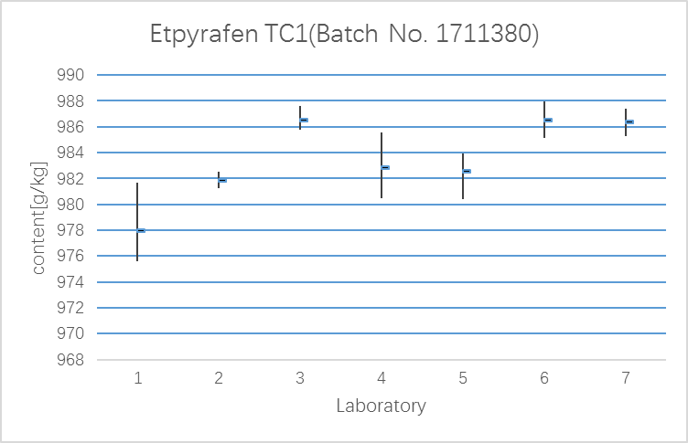

Table 2: Etpyrafen SC1 (Batch No: 171283A)
Lab | Day 1 |  | Day 2 |  | Mean  g/kg | Std. Dev.
Lab | A | B | A | B | Mean  g/kg | Std. Dev.
1 | 301.12 | 302.42 | 302.87 | 302.40 | 302.20 | 0.75
2 | 302.46 | 307.08 | 301.09 | 304.24 | 303.72 | 2.59
3 | 307.38 | 307.46 | 307.36 | 307.21 | 307.35 | 0.10
4 | 302.99 | 304.82 | 303.21 | 303.12 | 303.54 | 0.86
5 | 300.95 | 301.88 | 301.73 | 301.44 | 301.50 | 0.41
6 | 301.24 | 300.54 | 300.34 | 301.30 | 300.86 | 0.49
7 | 301.32 | 300.65 | 300.80 | 301.10 | 300.97 | 0.30

Fig.2: Etpyrafen SC1 (Batch No: 171283A)
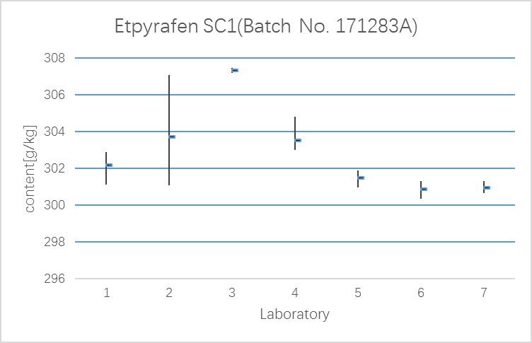

Table 3: Etpyrafen SC2 (Batch No: 171269A)
Lab | Day 1 |  | Day 2 |  | Mean  g/kg | Std. Dev.
Lab | A | B | A | B | Mean  g/kg | Std. Dev.
1 | 302.48 | 303.67 | 304.19 | 305.06 | 303.85 | 1.08
2 | 307.65 | 309.39 | 299.37 | 308.60 | 306.25 | 4.64
3 | 307.30 | 308.61 | 306.97 | 308.36 | 307.81 | 0.80
4 | 306.23 | 306.67 | 304.44 | 305.25 | 305.65 | 1.00
5 | 302.99 | 303.15 | 302.70 | 302.22 | 302.77 | 0.41
6 | 300.90 | 300.30 | 301.00 | 300.41 | 300.65 | 0.35
7 | 300.53 | 300.33 | 300.26 | 300.87 | 300.50 | 0.27

Fig.3: Etpyrafen SC2 (Batch No: 171269A)
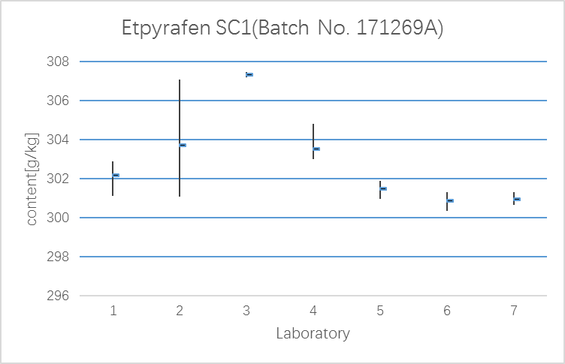

Summary of the results
Table 4 Summary of the results of all laboratories
 | TC-1 | SC-1 | SC-2
x | 983.57 | 302.88 | 303.93
L | 7 | 7 | 7
S_{r} | 3.19 | 2.28 | 2.81
S_{R} | 0.75 | 0.84 | 1.54
r | 3.28 | 2.43 | 3.20
R | 8.94 | 6.39 | 7.86
RSD_{r} | 9.18 | 6.80 | 8.97
RSD_{R} | 0.32 | 0.75 | 0.92
RSD_{R(Hor)} | 0.33 | 0.80 | 1.05
( values given in units of g/kg )
Where:
x = average, in unit of g/kg
L = number of laboratories
S_{r} = repeatability standard deviation
S_{R} = reproducibility standard deviation $=\sqrt{(S_{r^{2}}+S_{L^{2}})}$
r = repeatability ( S_{r}·2.8 )
R = reproducibility ( S_{R}·2.8 )
RSD_{r} = repeatability relative standard deviation ( 100·S_{r}/x )
RSD_{R} = reproducibility relative standard deviation ( 100·S_{R}/x )
RSD_{R}(Hor) = Horwitz value calculated from: 2^{(1-0.5log c)}
where c = the concentration of the analyte as a decimal fraction

Statistical formulas
Yi = mean of the various laboratories
Si = standard deviation
P = number of laboratories
n = number of measurements ( here n=4 )
$$T_{1}=\sum_{i=1}^{p}{\text{Yi}}$$
$$T_{2}=\sum_{i=1}^{p}{{\text{Yi}}^{2}}$$
$$T_{3}=\sum_{i=1}^{p}{{\text{Si}}^{2}}$$
Repeatability and reproducibility were calculated as follows:
$$S_{r^{2}}=\frac{T_{3}}{P}$$
$$S_{L^{2}}=\frac{{\text{PT}}_{2}−T_{1^{2}}}{P(\text{P-1})}−\frac{S_{r^{2}}}{n}$$
$$S_{R^{2}}=S_{r^{2}}+S_{L^{2}}$$
$$r=2\text{.}8∗\sqrt{S_{r^{2}}}$$
$$R=2\text{.}8∗\sqrt{S_{R^{2}}}$$

Discussion
Following the successful outcome of the small scale collaborative study organized by SYRICI, the small scale collaborative study was initiated in April 2018 to test a specific HPLC method for the determination of Etpyrafen.

7 laboratories had announced to participate the trial and sent back results.

The data from each of the laboratories were reviewed to determine if there were any problems with analysis procedure, chromatography or reporting results, which might affect the analyses results. The changes, deviations, and observations which were noted will not be expected to affect the analyses results significantly.

There were no stragglers or outliers according to Cochran test and Grubbs test.

The Horwitz criteria are fulfilled for TC1, SC1 and SC2.

Conclusion:
We would like to launch a large scale collaborative trial on the analytical method for Etpyrafen TC and SC.

Acknowledgements:
The organizer wishes to thank all laboratories and their staff who participated in this study.

